[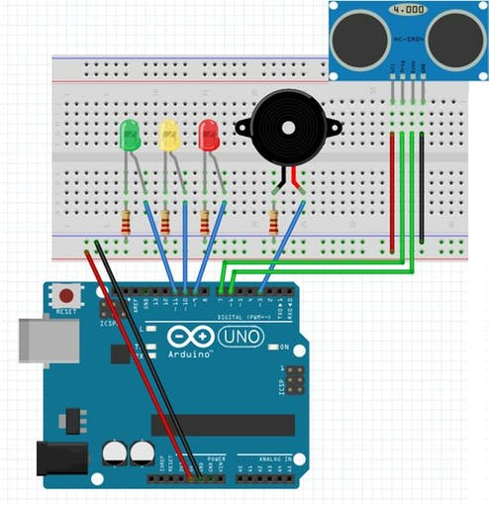](javascript:openLightBox('8ce33d513e',%200);)

**Ultrasonic Alarm**